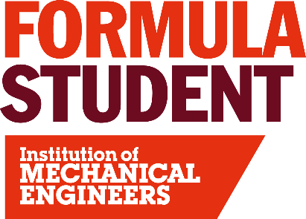
Technical Scrutineering

The key objective of the Scrutineers is to assist the teams conform to the rules which ensure driver and spectator safety is optimised. The Scrutineers take an objective, proactive and common sense approach to help the teams proceed to the dynamic events.
All components and accessories of the cars relevant to safety are inspected and any weaknesses are fed-back to the teams along with practical solutions to help them progress through the subsequent tests and ultimately on to the dynamic events. Key elements such as the placement and fastening of fuel, braking and intake systems are checked along with the operation of the emergency cut-off switches. This is the first test all the cars will have to go through and once passed, the car will be awarded the first “Tech” sticker and can proceed to the next check – the Tilt Table.

Experience required
You need knowledge of the FS rules, which can generally be gained from either studying them or from familiarity gained when designing a car in previous years. Those who are a first-time scrutineer will be placed with a more experienced scrutineer initially.

To apply to be a Technical Scrutineer at Formula Student 2026 please click here: Application

