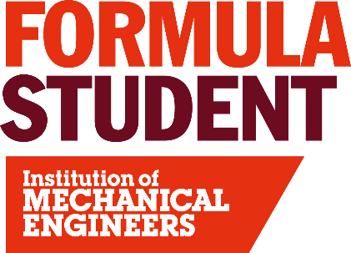
Media Operations
Each year a team of volunteer photographers, videographers and editors record and present amazing photography and videography of the live event.

To demonstrate this best please follow these links to see some of the images and footage that this team produce:

- Event Photos https://www.flickr.com/photos/fsuk/albums
- YouTube: Formula Student 2025 Highlights https://youtu.be/ENN4xc8wx_I?si=Kk6y6atZfufz3F52

Media operations volunteers should possess:
• Experience in photography and/or videography.
• Experience in editing.
• Ideally an interest in motorsport and/or engineering.
• The ability to get to and from Silverstone Circuit.

To apply to be a Media Operations volunteer at Formula Student 2026 please click here: Application
Please include a link or reference to look at your photo or video work. Applications without an accompanying body of work cannot be considered.

