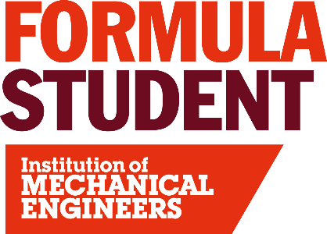
FS-AI Formula Student Artificial Intelligence (FS-AI)
FS-AI challenges university teams to build and develop the driving systems to run a fully autonomous vehicle. Teams compete in a number of static events similar to the manual FS competition including Engineering Design and Business Plan Presentation, but with Cost and Manufacturing replaced by a Real World AI event where teams must demonstrate their understanding and analysis of the integration of autonomous vehicles into commercial deployments around the world. In 2020 a new Simulation Development event was added where teams are encouraged to showcase and explain their virtual development of algorithms, vehicle models and environments.
Teams must also complete a series of exciting autonomous missions, again mirroring the manual FS competition, with Acceleration, Skid Pad, Sprint and Track Drive (Endurance) events. These demonstrate teams’ technical knowledge and understanding as well as the effectiveness of their autonomous driving systems. There are two different vehicle types the teams can use to enter FS-AI: Automated Driving System (ADS) and Dynamic Driving Task (DDT), both competing on the same track.
ADS: Teams compete with an autonomous car that they have developed and built completely themselves, such as previous competition entries from Starkstrom Augsburg and Team Bath Racing Electric. This is intended for experienced, multi-disciplined teams who are either developing existing FS cars to have driverless capabilities or vehicles they are building from scratch, and is allowed to be a second or third generation vehicle used before at competition.
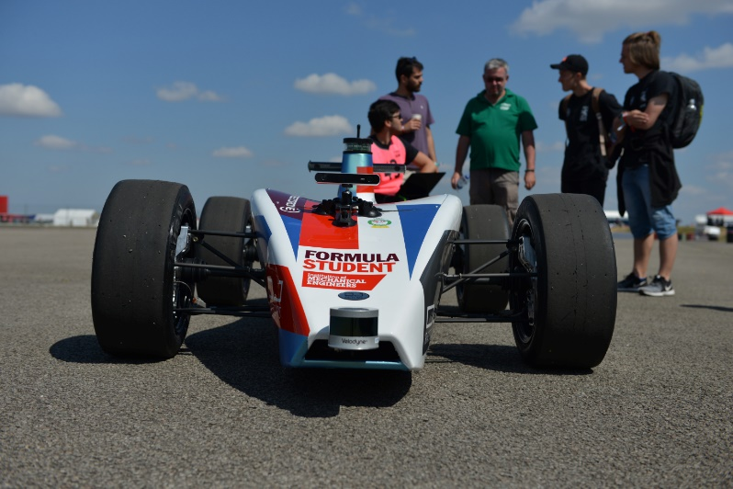
DDT: Designed as a starting point for new teams, teams can share a bespoke vehicle platform, the Autonomous Driving Systems – Dedicated Vehicle (ADS-DV), which has been developed exclusively for the FS-AI competition. The vehicle is supplied ‘autonomous systems ready’ so that teams may select their own controller and sensors. This option removes the requirement to design and manufacture a vehicle, leaving teams free to focus on developing their software. There is also the option to have shared use of the two prototype ADS-DV which are owned by the IMechE and have a PC and sensors already supplied.

FS-AI Volunteering
To support the continued expansion of FS-AI in 2023 we are looking for FS-AI specific volunteers for the event, with several ways in which you can be involved:
FS-AI Static event Judging
The students in each team depend on their Static event presentations to get them crucial points in the competition, but also to get valuable feedback from the judges on their designs. FS-AI judges evaluate the student’s understanding of what they have created by analysing their decisions, often asking tough questions, as well as their grasp of both technology and business applications of real world autonomous vehicle industries. It’s a fun, rewarding experience and a great opportunity to get up close to future stars of the industry and their state-of-the-art inventions.
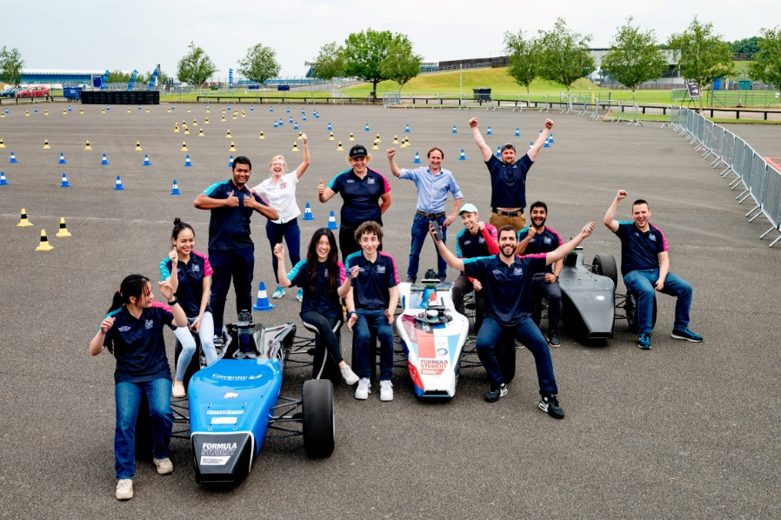
FS-AI Dynamics Events Support
The FS-AI competition runs a completely separate set of Dynamic Events to the main competition. Volunteers are required to ensure these events run smoothly and successfully. This is a great opportunity to see the FS-AI cars up close and support the teams in having a great competition experience.

FS-AI Garage Support
Anyone with IT or Automotive systems or software experience is invited to join the FS-AI Garage Support team. This involves supporting the DDT teams who will share the IMechE ADS-DVs to make the most of their time with the vehicles. Informal training will be provided, but the key requirement is enthusiasm! This is a great opportunity to get involved with the technicalities of FS-AI.

Volunteers applying to be involved in judging of the FS-AI competition should ideally be able to demonstrate industry experience in autonomous vehicle development and/or artificial intelligence. In addition, an outgoing personality with a friendly approach to people is highly desirable.
To apply to be an FS-AI volunteer at Formula Student 2024 please click here: Application

