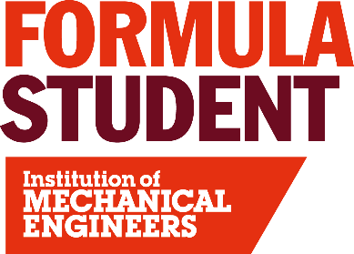

Electric vehicle scrutineering
With more electric vehicles in the competition than ever before the need for EV Scrutineers continues to increase. Scrutineers inspect and appraise the components of the car and designs of subsystems for safety and rules compliance, according to a set checklist. Our scrutineers assist the teams with an impartial, proactive and common sense approach to help the teams’ vehicles proceed safely to participate in the dynamic events.

Experience required
To be an EV Scrutineer you will need a sound knowledge of the FS rules, which can generally be gained from either studying them or from familiarity gained when designing a car in previous years. Support is available from the EV team in advance of the competition to ensure clarity and consistency in how the rules are enforced. Furthermore you should have experience in the field of electric vehicles, high voltage power electrical systems, or another similar, relevant discipline because EV scrutineering requires the volunteer to understand and be able to evaluate risks associated with high voltage AC and DC systems. Volunteers that are a first-time scrutineer will be placed in a team with more experienced scrutineers to support them.

To apply to be an EV Scrutineer at Formula Student 2026 please click here: Application

