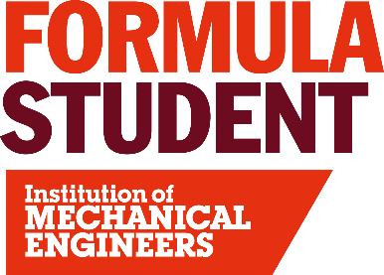
Cost and Manufacturing
There are two main classes of vehicles at the event, Formula Student (FS) Class and Concept Class (CC). FS Class incorporates all running vehicles competing in the dynamic events. Concept Class entrants are typically a rolling chassis, or concept in preparation for FS Class. 2026 will also see the requirement for teams to evaluate the cradle to gate greenhouse gas emissions associated with the construction of a prototype race car.
What the student teams submit:
Student teams submit a Costed Carbonised Bill of Material (CCBOM), Supporting material and Cost & Emissions file before the event, detailing the manufacturing processes, material selected, associated costs and Carbon Footprint (CO₂e) for a specified system(s). This documentation is pre-assessed by the Head & Deputy judges before the event to give a comparative guide to the Cost judges at the event.

Cost Judging:
Teams are allocated a 45 min slot whereby Cost Judging takes place. Student teams present to the judges with their car and supporting documentation. During the judging session the submitted documentation is reviewed to demonstrate that they accurately represent the vehicle presented. The team’s knowledge of manufacturing processes, costs and greenhouse gas emissions associated with the construction of a prototype race car is also established through discussions with the team.

Cost Final Judging:
The Cost Final is held on the Saturday of the event, hosted by the head and deputy cost judges where the final scores are achieved for this event. Teams that have scored the highest will be given the opportunity to present their knowledge and understanding again to define the final positions for the whole Cost Event.

Experience required:
Judge candidates can have a wide range of skills and we would not limit applications should candidates feel they have any shortfalls. We always make sure that judging teams have a range of skill sets and would never ask inexperienced judges to act in a capacity they were uncomfortable with. An example of skill sets and job roles of previous Cost and Manufacturing Judges are detailed below. Please note this list is not exhaustive:
- Cost and Process Engineers
- Mechanical Engineers
- Electrical Engineers
- Civil Engineers
- Process Engineers
- Accountants
- Procurement and Supply Chain Specialists
- HR Business Partners
- Tooling and Machinist
- Project Managers
- Charity Leaders
- Junior / Middle / Senior Managers / Board / CEO
- Academics or Teachers
- Past Formula Student Participants that had a particular focus on the Cost Event

To apply to be a Cost and Manufacturing Judge at Formula Student 2026 please click here: Application

