

APPRENTIC AUTOMATION CHALLENGE

2026

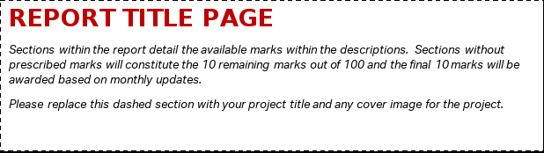

Team Details
Team Name
Project Name
Company

Team Members

First Name | Surname

Contents
List the contents of the report by page number.

Introduction
Briefly introduce the contents of the report and summarise the conclusions.
Word Limit: 750

Problem and Concept
Clearly define the problem you're addressing. Explain the concept or idea behind your proposed solution, including any initial research or inspiration that led to it.
Word Limit: 1500

Design Specification
This section is worth 20 marks. This section should include all relevant design documentation such as technical drawings, 3D model views, and system architecture diagrams. Describe any unique or critical features of your proposed system, supported by visuals and technical explanations. Be sure to include any calculations, assumptions, and design considerations that influenced your decisions.
Word Limit: 2500

Prototype Development
This section is worth 20 marks. Describe how you planned and developed your prototype, including the tools, materials, and methods used. Detail the steps taken to build and test the prototype, and explain any changes made to the design during the process. Use photos, diagrams, or other visuals to support your explanation and show how the prototype evolved through development and testing.
Word limit: 1500

Manufacturing Process
This section is worth 20 marks. Provide a detailed overview of how your product will be manufactured, starting with the prototype and extending to mass production. Include specifications, materials, and methods used, along with your proposed processes for scaling up and distributing the product. Justify your decisions with supporting data or research where possible.
Word Limit: 2500

Business Case
This section is worth 20 marks. Present a business case for your proposed system, including market research, cost and profit projections, and logistical considerations. You may also include competitor analysis, pricing strategies, and any other relevant business insights that support the commercial viability of your product.
Word Limit: 2000

Final Summary
Summarise the key points of the report. Reflect on the project’s success, challenges faced, and potential next steps or improvements.
Word Limit: 1000

Appendix

